The First Year: A Beginner’s Guide to the Most Common Mosses of the Gila
By Russ Kleinman & Karen Blisard
Introduction
“They all look the same to me—you mean there’s more than one? How many are there? “
Those are questions I had one year ago when I started looking at mosses in the Gila. Maybe some of you have had these questions also. There are thousands of species of mosses in the world, hundreds in the state of New Mexico, and probably over 200 in the Gila National Forest.
I wanted to know how to identify which moss was which—to put a name to them. Most mosses don’t have accepted common names, so they go by their Latin names. That makes things more difficult for some people, but you do get used to it. The biggest problems were the lack of a good, beginning guide to the mosses of our area to use and the absence of someone in my neighborhood who could get me started.
I have been studying mosses for the past year—that probably qualifies me as an advanced beginner. I am not a PhD botanist, and I don’t have any special qualifications. However, I do remember very well the problems I had learning mosses over the past year. With this book I hope to pass on some of the lessons I have learned and, in doing so, make your experience a bit easier and richer.
The First Problem: How do you tell what is a moss from what isn’t?
We all have a basic idea of what a moss looks like. They’re usually small green plants; they are so small in fact that we only notice them when they are grouped in large clusters of hundreds or thousands of individuals. There are, however, lots of small green plants that aren’t mosses. It is easy to mistakenly collect spike moss, leafy liverworts, and even algae because they look superficially like moss. First, you’ll never see a flower on a moss. You will see little urn-shaped capsules on stalks above many mosses, but they are not flowers. Second, all mosses have leaves, although they are sometimes very tiny. That leaves out the algae. Unlike leafy liverworts, these moss leaves are mostly longer than wide, usually have at least a rudimentary “midvein” called a costa, and the leaves do not have the large yellowish brown oil bodies that are characteristic of many liverworts. Although liverworts, mosses and hornworts are collectively known as the “bryophytes,” they are completely separate evolutionary lineages. Hornworts aren’t a problem—they don’t look much like moss and none have been collected to date in the Gila.
Spike moss—Selaginella in particular—caused me some problems in the beginning and made it into my moss collection packets more than once. The leaves of mosses are generally only one or two cells thick and are relatively flimsy. The leaves of Selaginella are thicker and tougher. The reproductive structures of Selaginella are kidney-shaped structures at the base of the leaves at the end of special stems and are not the capsules on stalks that we see in mosses.

Where Can I Find Moss?
This is the good part—mosses are nearly everywhere in this area. There are at least two mosses to be found growing in sidewalk cracks in downtown Silver City. There are more growing in Big Ditch Park. By the time you get to the forest itself, you’ll be in moss overload. Most mosses like rock surfaces or soil in moist, shady places. Some can be found growing on tree trunks. A few mosses here only grow submerged in flowing rivers or creeks. It is very important to note on what substrate you find the moss growing. Some are quite picky and only grow on limey rocks, others only on rotting wood, and so on. This information can help you identify your moss.

Now that I have found a moss, what do I do?
You will need a small portion of moss to examine, about one or two square centimeters. A small jackknife helps lift moss out of sidewalk cracks and off of rocks or bark. At this point, you will appreciate having a 15X hand-lens so that you can take a closer look at your find in the field. It is always better to collect a specimen that has reproductive capsules on it, as they are sometimes necessary for identification. You can get an idea in the field of the size and shape of the leaves, and whether or not they have a costa, the “midvein” of the moss leaf.
One of the first things you will want to note is the growth pattern of your moss. Some mosses grow basically upright and minimally branched. This growth pattern is called “acrocarpous.” The reproductive capsules of acrocarpous mosses usually arise from the end of stems. Other mosses grow more or less horizontally and are freely branching in a pattern called “pleurocarpous.” The capsules of pleurocarpous mosses grow out laterally from the branches. Most mosses can easily be fit into one of these two categories.
Many mosses are identifiable all the way to species in the field by just using a hand-lens. A whole book was written about doing just this in 1905 by A.J. Grout, a famous American bryologist. You will need to develop a familiarity with some of the more common moss genera before you can start to recognize mosses in the field.
After you do a quick examination of your find in the field, the next thing to do is to put it away so that you can examine it later under magnification. This is one of the stumbling blocks that keeps many people from enjoying mosses-- you must have eventually have access to both a dissecting microscope and a compound microscope to really understand mosses. More about that later; for the moment, you need to put your moss into a folded piece of paper. These first moss packets are temporary just for the field.
Using a standard piece of 8-1/2” by 11” paper (or waterproof paper if you want to be fancy,) fold the bottom up just under halfway, then the sides in about an inch or so, and lastly the top down. That should form a nice pocket in which to place your collected moss specimen. Before you insert the moss, write the pertinent collection info on the front of the pocket. If you’re like me and prefer to write as little as possible in the field, type up packets ahead of time with choices on the front that you circle. I put the most likely habitat information on the front to be circled when appropriate, along with the most common place names that I visit and the likely substrates among other things. As each of the packets is filled, it can be placed in a fanny pack or a suitable bag. The mosses should not be placed in baggies or plastic bags as they seem to deteriorate quickly in them.

Next stop, the microscope!
Now you are ready to find out what you’ve collected, to identify your moss sample. First, I recommend that you look at the moss in the dry condition if possible on a slide under the dissecting scope. Using a very fine forceps, remove a single stem from the tuft and place it on a slide. You only need 3-5mm of the stem. Sometimes the dry morphology of the stems and leaves is diagnostic. Be careful and move slowly lest static electricity should whisk your small dry moss into the unknown.
After you have a good idea of what the moss looks like dry under the dissecting scope, moisten it with one drop of water from a dropper or dip the stem for a few seconds in a cup of water and place it back on the stage of the dissecting scope. Then you can examine the structure of the moistened moss. Some mosses such as Syntrichia ruralis (a common moss in our area) change shape quickly and strikingly when wet. Sometimes I then place a cover slip over the entire stem in the wet condition to examine it under higher power with intact leaves looking for specialized asexual reproductive structures called “gemmae,” stem appendages called “paraphyllia,” and the presence of anchoring rhizomes on the stem.
Next you need to remove several leaves from the stem under the dissecting scope to view them properly. The leaves should be removed as close to the stem as possible, retaining the very bottom of each leaf as much as possible. There are two ways to do this. The first way works best with leaves that come off easily. With one forceps, grasp the youngest end of the stem. With the other forceps, strip the leaves off by gently following the contour of stem back towards the base. This method removes many leaves quickly when it works. Sometimes, though, the leaves won’t strip off easily and the stem repeatedly breaks up instead. On other occasions, too much of the base of the leaf is left behind on the stem. As you will find out, the base of the leaf contains much of the information we use to identify moss.
The second method for removing leaves from the stem involves grasping each leaf individually and then gently rotating it downwards with a fine forceps. This is more time consuming but allows more control over the process. Sometimes this is the only method that works. Other times, both methods work equally well and then stripping the leaves off the stem gets the job done faster.
After several leaves have been separated from the stem, remove the rest of the stem and other debris from the slide. Next place a cover slip over the slide. Using a dropper, add just enough water at the edge of the slide to evacuate the air from underneath the cover slip. After you have prepared the slide, place it on the stage of the compound microscope. Now it’s time to closely examine the leaf size and shape, the nature of the costa (midvein), the shape and clarity of the individual leaf cells, the presence or absence of bumps (papillae) on the cells or special plates or hairs on the top of the leaf, and the margin of the leaf. It is important to observe the characters carefully, as the difference between two species can be quite subtle. Along with the size of the moss and appearance under the dissecting scope, this additional information is sufficient to identify many mosses to genus and species.
There are three main areas of the leaf—the base including the “alar” region, the middle portion of the leaf, and the leaf apex. Each area provides diagnostic information to help figure out the identity of a moss. The alar cells are cells at the base of the leaf that are frequently different in size, shape or color from the cells just above them on the leaf. The base and middle portion of the leaf (the flat part of the leaf not including the costa is often called the “lamina”) of the leaf can also be “plicate,” which means folded or creased. The apex (leaf tip) is usually described as “acute” or “obtuse”, depending on the angle the two sides of the leaf make with the apex. If the angle is greater than 90 degrees, it is described as obtuse. If the angle is less than 90 degrees, it is described as acute. Basically, a sharp leaf tip is acute, a blunt one is obtuse.
Sometimes it is important to know the internal structure of the costa (midvein) and to know how many cells thick a leaf is. The only way to determine this is to make a one cell thick cross section of the leaf. It sounds impossible, but it this can be done with a razor blade and a dissecting probe on a slide. The probe is used to press down on a stack of leaves or a stem. The razor blade then cuts the sections using the probe as a “fence” or guide. Each time a section is cut, the probe is rolled back on the leaves a small ways exposing a very small bit for the next section. Making this type of cross section takes quite a bit of practice and is best left for later if you’re just getting started with mosses. The Pottiaceae and Grimmiaceae are two moss families that are well-represented in the Gila National Forest, and they both frequently require leaf cross sections when keying out a moss.
Unfortunately, there are dozens if not hundreds of confusing and sometimes ambiguous terms used to describe moss parts. Luckily, most books that include keys also include a glossary of the terms that are used in the keys. Some of the most dog-eared pages in my moss books are pages in the glossary.
Keys can be difficult to use in the beginning—using them is a skill that takes practice. They involve making decisions about what your moss looks like—is it large or small, black or green, growing on rock or wood, and so forth. Keys commonly require you to note the presence or absence of certain structures, such as teeth on the leaf margin. Perhaps the most frustrating part about moss keys is the frequent requirement for sexual reproductive structures to be present. Without these sexual reproductive structures, mosses in the Grimmiaceae (family names end with –aceae), Orthotrichaceae, Funariaceae and Bryaceae especially the Pottiaceae can be difficult to identify to species.
How do you recognize the various sexual parts of the moss? It actually is not very difficult; it is just the vocabulary that can be hard when you’re just getting started. Mosses (and many other organisms) have two basic parts to their life cycle—the gametophyte stage and the sporophyte stage. The gametophyte stage of a moss is the usually green, leafy moss that we’re used to seeing and that most of us actually think of as the moss. This stage of the moss life cycle is called the “gametophyte” because it makes the gametes. The female gamete is the egg, and the male gamete is the sperm. The egg and sperm join to grow into the next stage which is called the “sporophyte.” The sporophyte is the capsule that holds the newly formed spores, the lid (called the “operculum”) and the area around the lid called the “peristome”, and the stalk that holds the capsule up called the “seta.” The moss sporophyte is very small compared to the gametophyte and can be overlooked. It is always best to collect mosses with the attached sporophytes if possible since sporophyte characteristics are sometimes required by keys.
Moss eggs are found in structures called “archegonia”, while the moss sperm originate in antheridia. Dr. Brent Mishler of the University of California at Berkeley refers to the locations of the archegonia and antheridia on a moss stem as the “oicky” –ness of the moss. If the archegonia and antheridia are both found on the same plant, the plant is referred to as monoicous. When the archegonia and antheridia are always found on different plants, they are referred to as dioicous.
There are additional words used to describe the location of the male and female parts on monoicous plants which have both archegonia and antheridia on the same plant. If the antheridia surround the base of the archegonia, the plant is referred to as “synoicous.” If the antheridia are at the bases of leaves just below the archegonia, the plant is called “paroicous.” When the antheridia and archegonia are in different buds on the same stem, then the plant is referred to as “autoicous.” If it seems like these distinctions are unnecessarily complicated, it is because the distinction is occasionally necessary to differentiate moss species. It takes patience and some practice to correctly identify the “oicky” –ness of a moss.
That’s quite a bit of information to glean considering the moss may only be a few millimeters tall! Finally, you’re ready to try out the key. Most keys are “dichotomous,” meaning that you are presented at each step of the way with a choice between two alternative descriptions (a “couplet”). You choose the description that most accurately reflects the traits that you have observed and follow the key to the next couplet. Eventually, if your observations and choices in the key are accurate, you will arrive at the identity of your moss. This can be quite a “Eureka!” moment.
You have a provisional identity of your moss based on the key. Now is the time to look through the pictures and descriptions of the mosses and find out if your conclusion fits. There is always some natural variation so that no two mosses will look completely the same, just as two people never look completely the same. Occasionally you will find that you don’t have the moss that the key seemed to say that you had. It is best either to start over and recheck your steps, or to go back to the last place in the key that seemed unambiguously correct. Sometimes there was a place in the key where both options seemed equally plausible and you just need to go back and take the other direction.
This guide doesn’t include all the mosses in the Gila; in fact, it includes a small fraction of them. However, only a few common mosses make up the majority of mosses you will see when you first start looking for them. The best way to get started is to study the mosses included here as the most common mosses of the Gila. This will jump start your ability to identify common mosses. When you first start using the keys, it is easier to key out a few specimens whose identities you already know. After you are more familiar with the vocabulary and how the keys work, it becomes easier to get a correct answer for your unknown mosses.

The Most Common Mosses in the Gila National Forest
The idea for this section came from California Mosses, by Malcolm, Malcolm, Norris & Shevock. Those of us attending sobefree 2011, an annual moss meeting on the west coast originated by Brent Mishler, used this book as a major aid to identifying mosses in Northern California. Many of us found the first section, the 20 most common mosses of California, to be particularly helpful.
It isn’t an easy job to choose which mosses to include here. The ones I ended up with belong to several different families. This way, you not only get a handle on some very common mosses but you also get a start recognizing features common to some of the moss families. I would recommend you study these common mosses first and try to see how they differ in the pictures. You will likely collect some of them among your first specimens. As you recognize them, you will gain confidence. Kelly Allred once told me that when I could recognize five mosses I would be one of the top five bryologists in New Mexico. If you can recognize these common ones, you’re well on your way!
Syntrichia ruralis (Pottiaceae)
Ceratodon purpureus (Ditrichaceae)
Bryum lanatum (Bryaceae)
Rosulabryum laevifilum (Bryaceae)
Coscinodon calyptratus (Grimmiaceae)
Pylaisiella polyantha (Hypnaceae)
Homomallium mexicanum (Hypnaceae)
Hypnum revolutum (Hypnaceae)
Brachythecium salebrosum (Brachytheciaceae)
Dicranoweissia cirrata (Dicranaceae)
Hedwigia ciliata (Hedwigiaceae)
Lescuraea arizonae (Leskeaceae)

Syntrichia ruralis (Pottiaceae)
Syntrichia ruralis is a moderate-sized to large moss that can be found in the foothills among the Pinons and Juniper growing on sand or rocks. Like most mosses, S. ruralis is harder to recognize when dry, but it expands and changes appearance dramatically when wet. As a dry specimen, the relatively large leaves (up to about 5mm) can look dark green to black with obvious white hair tips. It is usually easy to tell even when dry that S. ruralis is relatively broad-leaved, unlike the Grimmias that can also have hair tips. The apex of the leaf is obtuse (blunt), and the edges of the leaf are turned back (recurved.) The margin of the leaf is smooth (entire) meaning that there are no teeth present. Under the microscope, the one of the most obvious features of S. ruralis is the presence of four “C-shaped” bumps (papillae) on cells in the upper part of the leaf, giving that part of the leaf an opaque appearance. One sure clue to the correct identity of mosses in the genus Syntrichia is that the midvein (costa) appears reddish even when dry. Syntrichia ruralis usually grows in obvious tufts.

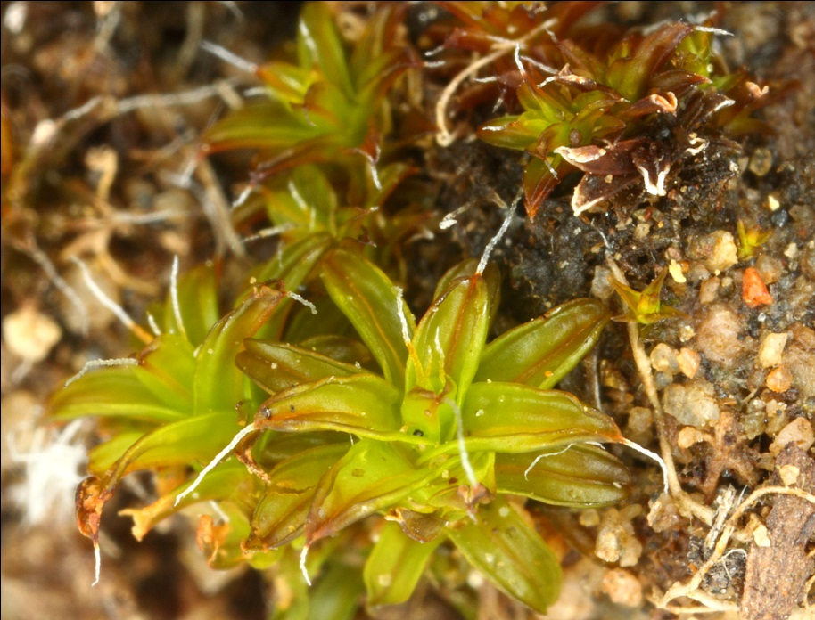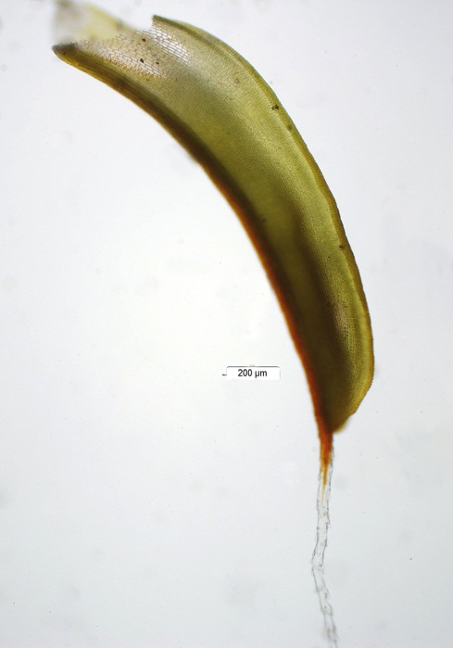
This is Syntrichia ruralis in the wet state. Notice that the hair tip (also called an “awn”) may have a
bit of reddish color at the base.

Ceratodon purpureus (Ditrichaceae)
Ceratodon purpureus is the first moss many people in the southwest encounter. In fact, C. purpureus has been described as “weedy” in the southwest. It forms yellow-ish green hemispheric mounds on soil or rock from lower, urban elevations all the way up to over 7,000 feet in the mountains. It is commonly found on downed, blackened logs as well. C. purpureus has long, thin leaves that have no teeth. The leaves are turned back (recurved) from the base almost to the apex. When the leaves are dry, they usually are erect on the stem and just a little twisty. After being moistened, many of the leaves bow backwards and develop a 90 degree angle about 1/3 up from the base. The cells of the distal leaf are square shaped under the microscope and very clear. Commonly there are a few large, coarse teeth at the leaf apex. If sporophytes are present, the identity is easy to determine because they have a long stalk that turns from yellow to purple with age and a long, green cap (calyptra) over the capsule that splits along one side before falling off.

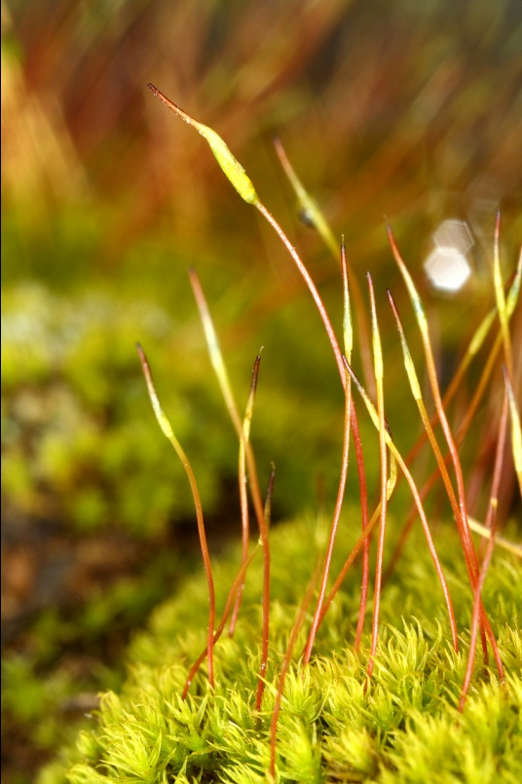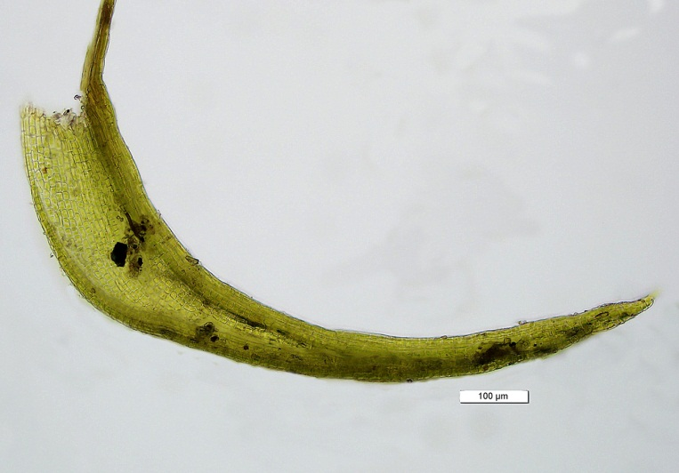

Ceratodon purpureus is quite variable in our area. Most mossers collect this one many times before they learn to confidently recognize it in the field.

Bryum lanatum (Bryaceae)
Bryum lanatum and its lower elevation urban twin Bryum argenteum are easy to recognize by virtue of the whitish color of the mature leaves. The acrocarpous (upright) growth habit along with this whitish appearance is completely sufficient to confidently identify these mosses that differ otherwise in the width of the leaf and length of the costa (midvein.) If you are in the Gila area and have a whitish acrocarpous moss, it will be Bryum lanatum. The leaves are tightly pressed against the stem, making the stems look ropey. This is called a “julaceous” growth form. Bryum lanatum can be found in urban environments growing in sidewalk cracks. In the wilderness, it is found most commonly on rocks and soil. It can inhabit rather dry areas and is also one of the first plants to become established on burned soil and rocks.

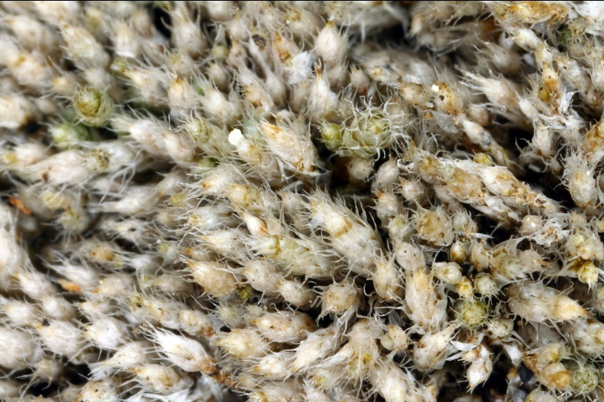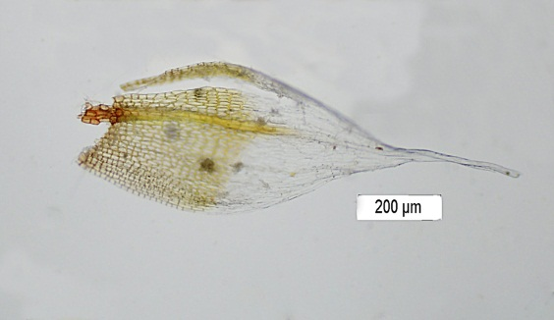

Hair tips are usually present, and when the costa extends all the way into the hair tip as in this photo, the moss is Bryum lanatum. If the costa stops short of the hair tip and the leaf base is broader, then you are looking at Bryum argenteum—which for obvious reasons is also known as the Silver Sidewalk Moss.

Rosulabryum laevifilum (Bryaceae)
Sometimes it seems like botanists are playing “musical chairs” with plant names, and moss names are no exception. For most of recent history, Rosulabryum laevifilum has been known as “Bryum capillare.” Unfortunately, the name “Bryum capillare” was used to refer to many different but similar mosses that are have since been split into several genera. Now, the genus Rosulabryum refers more specifically to a moss with a leaf that is broader toward its apex than near the base with leaves are arranged in a rosette clustered at the apex of the stem. Usually, there is a nubbin of a hair tip, with a few teeth on the leaf margin near the apex. Like all Bryums, the leaf cells are six-sided with the two sides parallel to the leaf edges longer than the others. Rosulabryum laevifilum commonly has little green linear structures made up of several cells in the angle between the leaves and the stem (the leaf axil). These are specialized asexual reproductive structures called “gemmae.”

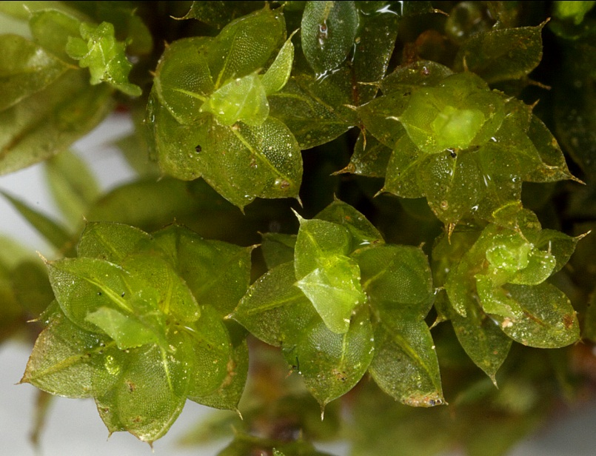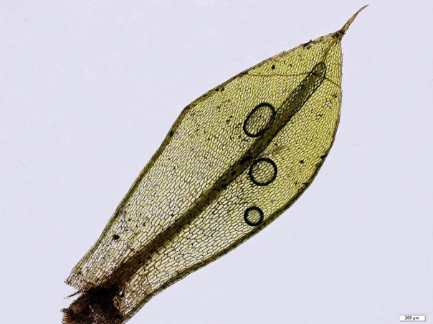

Rosulabryum laevifilum is not like most of the other mosses in the “most common” list in that it usually doesn’t form extensive mats. It can frequently be found growing as small groups of stems among other mosses.

Coscinodon calyptratus (Grimmiaceae)
The Grimmias as a group are easy to recognize—these mosses have hair tips and usually form dark green to black well-formed mounds occurring on boulders. However, identifying members of the Grimmiaceae to the species level can be very challenging and usually requires leaf cross sections. Thankfully, Coscinodon calyptratus is very common and is one of the easiest lower elevation Grimmiaceae to identify. C. calyptratus has long hair tips that can be longer than the leaf itself, and it has capsules that usually are “exserted”, which means that the stalk to the capsule (the seta) is usually as long or longer than the capsule itself such that the capsule sticks up above the level of the leaves below it. The covering over the capsule, called the “calyptra”, is long and covers the entire capsule. There are no papillae (bumps) on the cells, which look quite clear under the microscope.

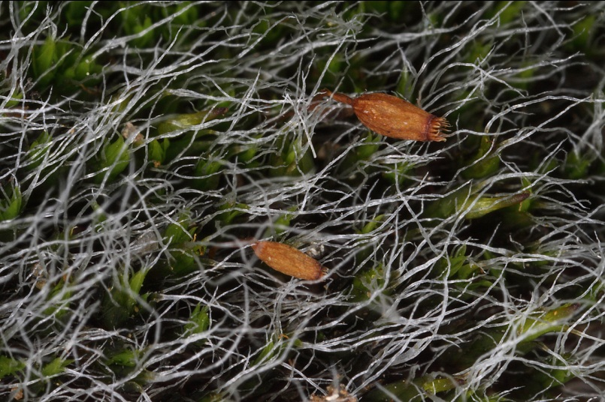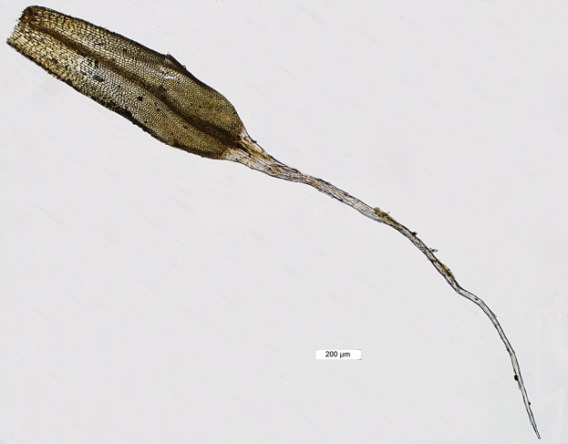
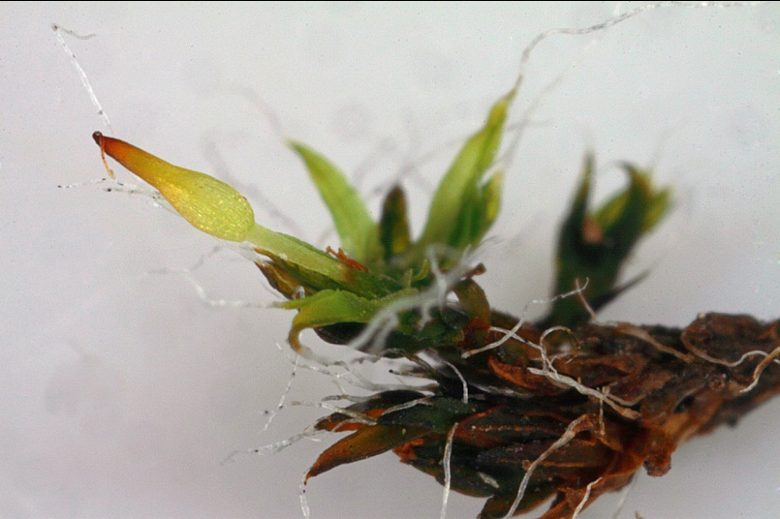
Notice that the covering completely encloses the capsule hidden within it.

Pylaisiella polyantha & Homomallium mexicanum (Hypnaceae)
Pylaisiella polyantha and Homomallium mexicanum look nearly identical in the field if they don’t have capsules on them. These are the two mosses that are most commonly found growing in abundance at the bases of Alligator Juniper trees, but they can also be found occasionally growing on rocks. They are pleurocarpous, meaning that they have a spreading growth pattern. They are usually light green in color. The leaf cells are quite a bit longer than wide, and not square or hexagonal. There are no teeth on the margins and although the leaf apices can be elongate, they are not blanched whitish as in a hair point. The best way to tell these two mosses apart in the field is by the orientation of the capsules if you are lucky enough to have them. The capsules of Pylaisiella polyantha are symmetrical and upright, while those of Homomallium mexicanum are asymmetrical and tilted.

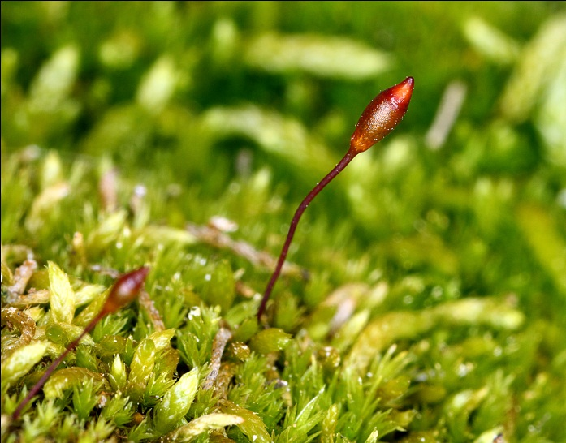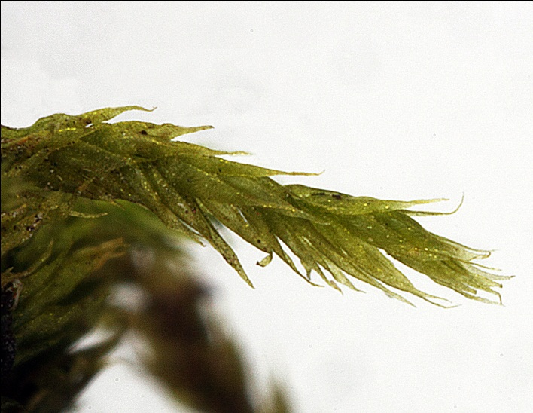
P. polyantha on left, H. mexicanum on right. Homomallium mexicanum can sometimes be identified by the apical leaves on the stem—they sometimes seem to all be pointing off to one side as in this photograph, like the hair on the tails of some long-haired dogs.

Hypnum revolutum (Hypnaceae)
Hypnum revolutum is only found at higher elevations, above about 8,000 feet. But once you get into its habitat, H. revolutum can sometimes cover large areas. It can be seen to cover tree trunks, rocks and bare ground where moisture is at least seasonal in cooler elevations. The regular pinnate (feather-like) branching pattern on a large yellow-brown moss is easily recognizable in the field, as are the falcate-secund leaves (leaves that are sickle shaped and turned the same direction.) Under the microscope, the costa is short and double, the leaf margin usually strongly revolute (turned back), and the leaf cells very elongate. In its usual form, H. revolutum is unmistakable for any other moss. Occasionally, the leaves are not very falcate second and the margins nearly plane—then the identification becomes pretty tough. Luckily, within its range here, H. revolutum usually has its characteristic appearance.

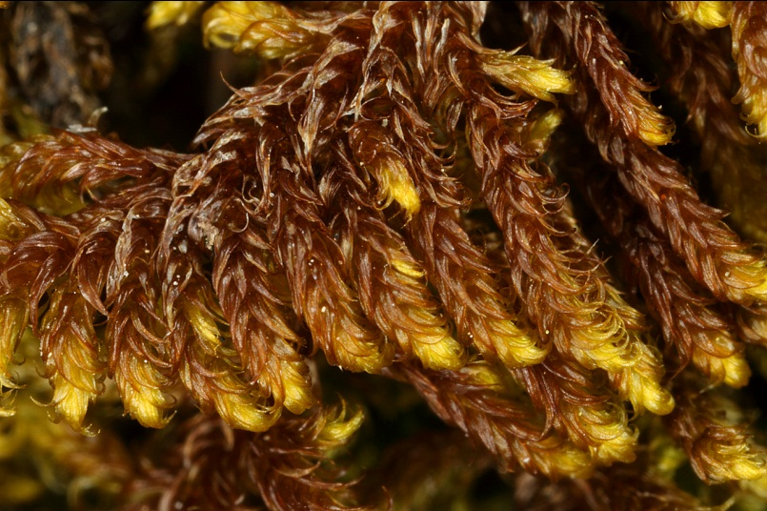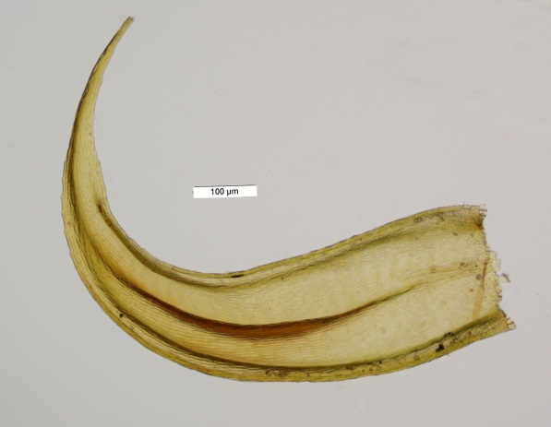

Hypnum revolutum is a beautiful moss in the field, one that you will learn to recognize quite easily. The other mosses of the genus Hypnum here are quite different in appearance. Hypnum cupressiforme, a moss that is very common elsewhere, is remarkably uncommon here.

Brachythecium salebrosum (Brachytheciaceae)
Brachythecium salebrosum is a larger middle to upper elevation pleurocarpous (horizontally branching) moss that grows on soil and over rocks in long thick strands that form ropey mats. It has a characteristic yellowish green color that you can learn to recognize. Microscopically, the leaves are pointed and have a deep fold (plicate) on either side that is most pronounced at the base and stretches over half way up the leaf. The leaf apex usually has small, shallow teeth. The costa is single but doesn’t reach into the apex of the leaf. It seems to stretch about halfway up the center of the leaf and then become too faint to follow. The leaf cells are elongate. There are several Brachytheciums in the Gila that are hard to tell apart, but they are Dr. Allred’s favorite genus and he has written a wonderful key to the Brachytheciums of New Mexico. The key relies heavily on the size of the moss, whether plicae (folds) or teeth are present, and the shape of the leaves.

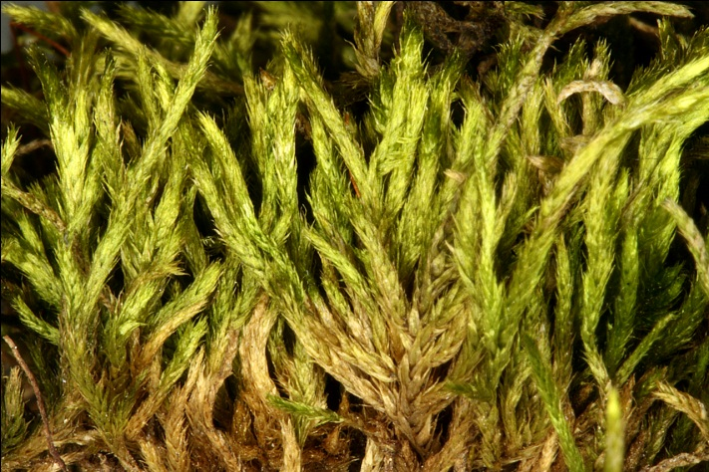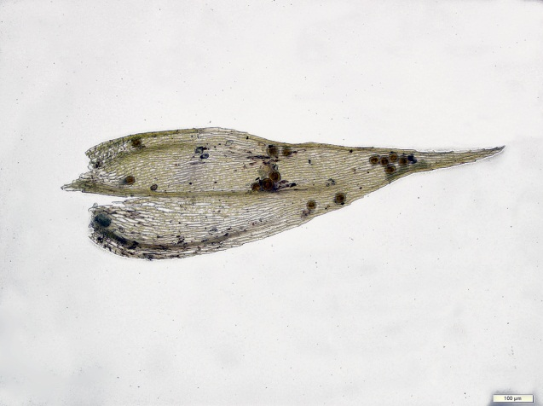

The leaves of Brachythecium salebrosum are loosely appressed to the stem, but the tips of the leaves can still be seen to spread a bit.

Dicranoweissia cirrata (Dicranaceae)
If you find a small moss with its leaves all curled up on rotting stumps or logs in the Gila, you more than likely have found Dicranoweissia cirrata. The stems are rarely more than a few millimeters high, and the tiny leaves are much longer than wide—long lanceolate (spear shaped) to nearly linear. The leaves are strongly curled (crisped) when dry but quickly straighten up when wetted, quite a remarkable transformation when viewed under a microscope. Another interesting finding are the gemmae found on the leaves—these are small multicellular outgrowths from the leaf that are intended to break off and propagate the moss. The leaf apices are coarsely toothed and the leaf cells are square to rectangular or oblong.

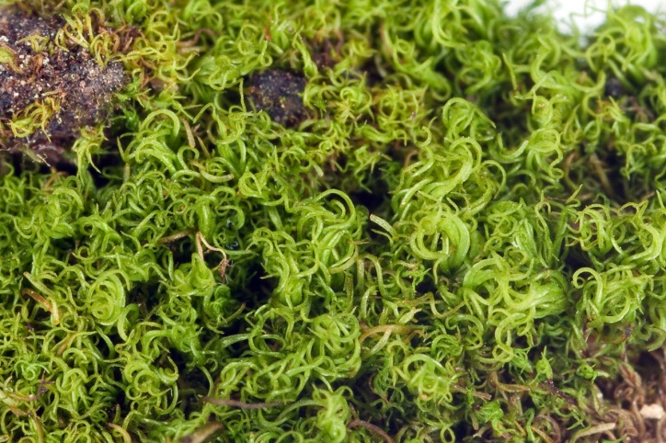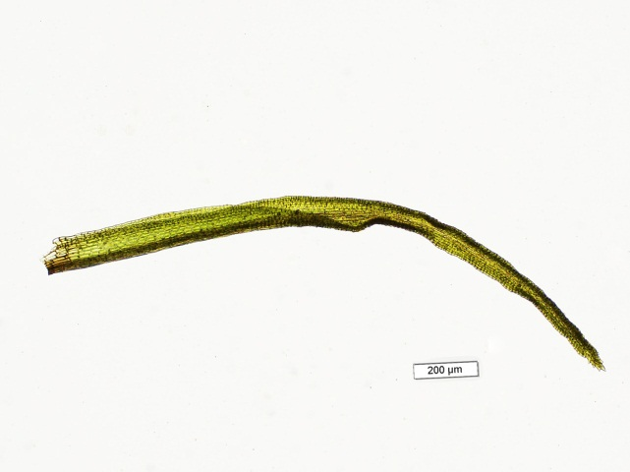
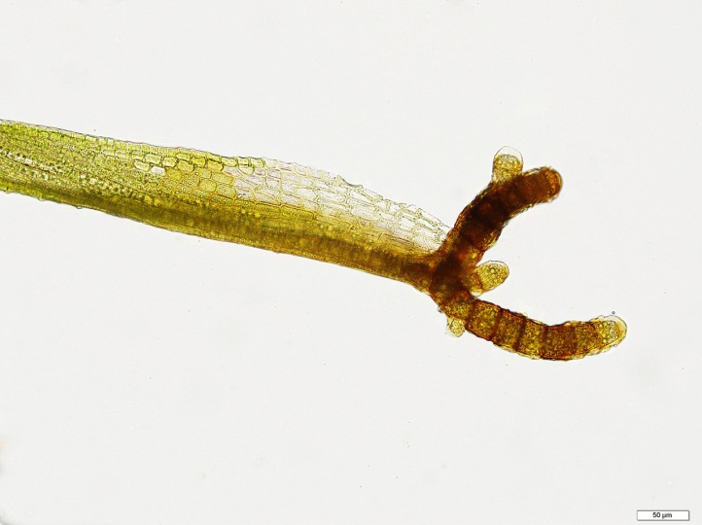
Upper left—Dicranoweissia in the dry state. Upper right—wetted leaf at 40x.
Bottom left—leaf base at 200x with gemmae.

Hedwigia ciliata (Hedwigiaceae)
Hedwigia ciliata has leaves that are blanched white in a triangle near the ends, a little bit like those of Bryum lanatum, but that is where the similarity ends and you will have no trouble telling these two mosses apart. Hedwigia ciliata stems are not packed tightly together like those of Bryum lanatum, and are not so vertically oriented. H. ciliata has no costa, and the leaf cells are uniformly quadrate (square appearing from the top.) The leaves of Bryum lanatum seem light and flimsy, while those of Bryum lanatum are stocky and firm appearing. Without capsules, Hedwigia ciliata might give you some trouble a time or two, but the capsules are unique—nearly round, orange, with a red ring (annulus) around the lid (operculum.) The capsules look eerily like aliens eyeballs when they are present!

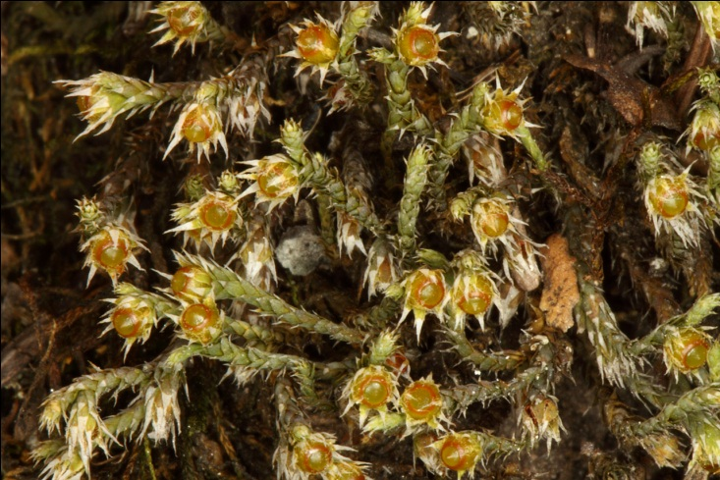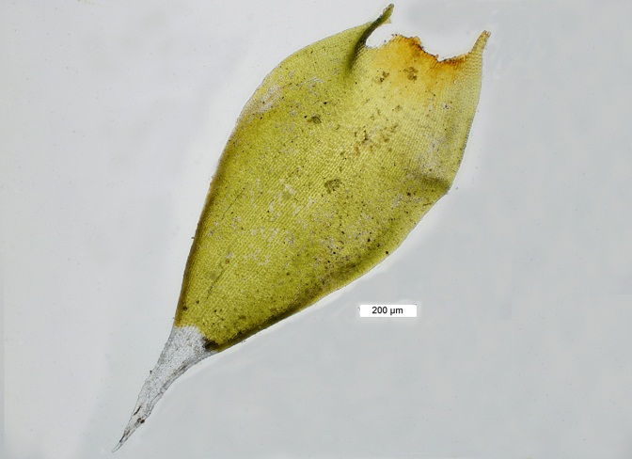

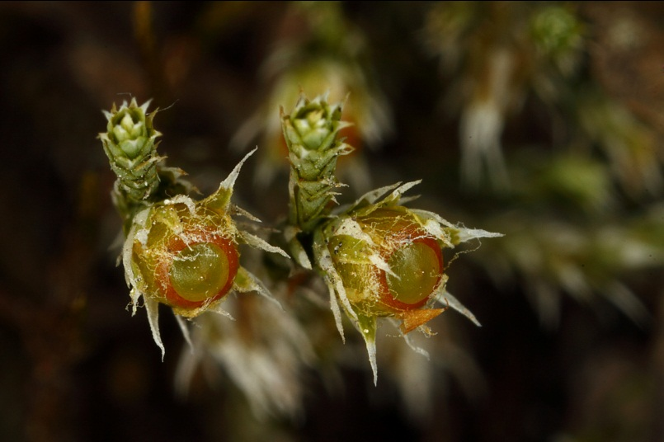

Those little “hairs” around the “eyeballs” are the source of the “ciliata” part of the name.

Lescuraea arizonae (Leskeaceae)
For those of us trying to identify mosses in the field, the Leskeaceae are pesky-aceae. As a group, they are very small mosses that are nearly impossible to tell apart in the field even with a good hand-lens. If you find a very small dark olive green moss with tightly packed rope-like stems in a rather large mat covering rocks and bases of trees, you have probably found Lescuraea arizonae. You will however have to take your find back to your microscope to be sure you haven’t collected Pseudoleskella tectorum or Lindbergia brachyptera, both of which can look just like Lescuraea arizonae in the field. Lescuraea arizonae has a very broad and strong costa and that distinguishes it rapidly from the other Leskeaceae. It is uncommon to find capsules on L. arizonae. Look for Lescuraea arizonae at middle elevations in moist canyons but at least several feet from the water.

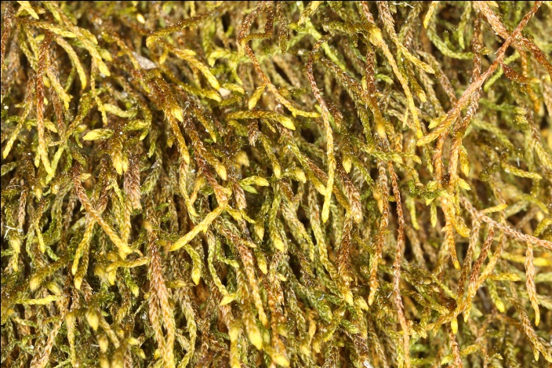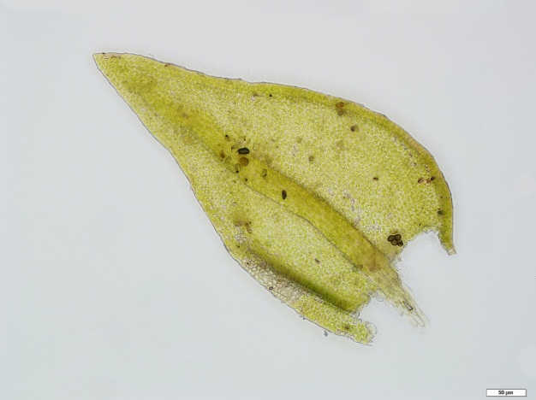

You can only go so far reading and looking at pictures. At some point, you just need to get out into the field and start looking at mosses. What are you waiting for!

Good luck mossing!
Russ & Karen
With Many Thanks to Dr. Kelly Allred, without whose help we would still be at square one!

